The
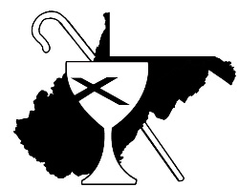
ChiRho
Catechism

A Disciples Dictionary
for your journey of faith

- 2016 Edition -

------------------------------------------------
Foreword
The information which follows is intended to help you on your journey with God and with the Church. It is intended to be a beginning place and thus is not exhaustive. It is general and yet also peculiar to our little corner of the whole Church, and so it includes words and concepts that are important to the Christian Church (Disciples of Christ).

Words matter! So, here are some words that have relevance and meaning. Wherever you are in life, I hope that this will help you better understand the language and theology of the Church. As you add your own thoughts to these in the days to come, may you bless the world through your life of faithful discipleship.
Thaddaeus B. Allen
Regional Minister and President
Christian Church (Disciples of Christ) in West Virginia
Christian Church (Disciples of Christ) in Pennsylvania

3
Preamble to the
Design
for the Christian Church (Disciples of Christ)

As members of the Christian Church,
We confess that Jesus is the Christ,
the Son of the living God,
and proclaim him Lord and Savior of the world.
In Christ's name and by his grace
we accept our mission of witness
and service to all people.
We rejoice in God,
maker of heaven and earth,
and in God’s covenant of love
which binds us to God and to one another.
Through baptism into Christ
we enter into newness of life
and are made one with the whole people of God.
In the communion of the Holy Spirit
we are joined together in discipleship
and in obedience to Christ.
At the Table of the Lord
we celebrate with thanksgiving
the saving acts and presence of Christ.
Within the universal church
we receive the gift of ministry
and the light of scripture.
In the bonds of Christian faith
we yield ourselves to God
that we may serve the One
whose kingdom has no end.
Blessing, glory, and honor
be to God forever. Amen.

4

The Lord’s Prayer
or
The Prayer of our Savior

Our Father,
Who art in heaven,
Hallowed be thy name,
Thy kingdom come,
Thy will be done,
On earth as it is in heaven.
Give us this day
Our daily bread;
And forgive us our debts,
As we forgive our debtors;
And lead us not into temptation,
But deliver us from evil.
For thine is the kingdom,
And the power,
And the glory, forever.
Amen.

5

What are some basics in Our Christian Life?

God has created us in God’s image and seeks us out and makes God known in our lives and in our inner being. We have been created for a life given to God. God is the creator of the world and of us. God is our Redeemer and Savior. God is sustaining us still today. Our lives in the church and in the world are God-given! All that follows reflects this truth.

The Greatest Commandment is to “love the Lord your God with all your heart, and with all your soul, with all your strength, and with all your mind; and your neighbor as yourself.” (Luke 10:27)

Holy means set apart by God or for God’s good purpose or use.

Worship is the church’s act of devotion and praise to God. It is often marked by singing, praying, preaching from the Scripture and by the observance of Holy Communion.

Prayer and Prayerfulness is about turning ourselves toward God in genuine and intentional ways. It is a gift to be received and given.

The Lord’s Prayer is the most common prayer of the Church. Many Christians say it several times throughout the day. (Matthew 6:9-15 and Luke 11:2-4)

Forgiveness is part of who we are and are called to be. In Christ we are forgiven, and our sins are not counted against us.

6
Evangelism means to share the Good News of Jesus with others.

Reconciliation is good term that we use in our relationships with God and one another. Reconciliation with others makes us one as God desires.

Stewardship is the understanding that all we have belongs to God. How we manage the resources of earth and self that God has entrusted to us should reflect our faith and gratitude for God’s abundance. Tithing (giving 10% of our income to the work of the Church) has long been understood as a basic mark of Christian stewardship.
How do We Speak About Our Faith?

Christians believe that God has been revealed to us in Jesus Christ.

Grace is God’s free and unmerited love for you and for the world.

The Good Confession is what we say when we confess Jesus as Lord and join the church. (Matthew 16:16)

Repentance means to turn back towards God (away from sin and things that separate us from God.)

Sin is activity, situations or systematic realities that separate us from God.

Salvation means to rest in the safe arms of God.

7

The Bible is the holy book of the church.

Gospel means “Good News”. The first four books of the New Testament (Matthew, Mark, Luke and John) are referred to as the Gospels.

The use of Reason is part of us. We are called to be thinking Christians and use our minds as well our hearts and souls in the worship and service of God.

Creeds are simply statements of beliefs. The Apostle’s and Nicene Creeds are used in many ways.

Trinity refers to the Godhead and is a way of speaking about God. The traditional is the Father, Son and Holy Spirit.

Christian Unity is Our Polar Star, as taught by Barton Stone. It is our unique calling to the whole church as Disciples. We love unity!

The Great Commission gives us the words of Lord about going into the world and sharing the gospel. (Matthew 28:16-20)

Disciples are students of Jesus. A life of discipleship is intended to be lived in a Christ – like manner.

8
What Can We Affirm About
the Church and Its Sacraments?

The Church (or the body of Christ or the Community of the baptized) is made up of believers and doers around the whole world. While we gather in different places and worship and serve in different ways, there is only one church.

Expressions or Manifestations of the Church – the church is made known locally, regionally and generally.

Congregation is a gathering of Christ’s people.

Assemblies are a big part of our life as church. We assemble to be a visible sign of the unity of the church and for the good works, worship, education and fellowship that are important to our lives. We have General and Regional Assemblies every other year in different places.
The name of our denomination (our little corner of the body of Christ) is the Christian Church (Disciples of Christ). We often simply refer to ourselves as Disciples. Thus we are to be students of Jesus.

Ecumenism is the vocation (work and life) of the church that seeks to promote Christian unity in and among different types of Christian traditions.

Seminary is a place of learning for the church. It is school.

9
Infant Blessing is an act of the church where we joyfully receive new life and new parents into our midst.

Anointing with Oil is used at various times as a sign of the presence of the Holy Spirit in the life of the person who is anointed. This may be in a time of prayer for healing, following baptism (see below), at an ordination, or at other times.

Ordination is the setting apart of a person for a specific ministry of the church through the laying on of hands by other set-apart persons and representatives of the church, and through prayer. Many of our pastors are ordained persons.

Baptism is a sacrament of the church. It is a Christian rite of initiation to join the church. It uses water and the Trinitarian formula. Baptism is done by immersion, sprinkling or pouring, though we normatively immerse believers who have made the confession. Baptism is done once in a person’s life and has been practiced since the beginning of the church. In baptism forgiveness and the gift of the Holy Spirit are received.

Each week we celebrate the Lord’s Supper, or Holy Communion, or the Eucharist (eucharist means “thanksgiving”) in our worship service. Christ has given us the gift of grace of being welcome at his table. Bread is broken and wine is shared (these are the gifts of creation that Jesus chose to hand on). In this moment the Church celebrates with thanksgiving the saving acts and presence of Christ still with us. Like baptism, in communion we are made one with God and one with each other. Holy Communion is a sacrament of the Church.

10
What are the Seasons of the Church Year?

Advent – a time of preparation for the holy day and season of Christmas. It is made up of four weeks and begins the church year. The color is purple.

Christmas – a feast of the Church which celebrates the Nativity (the birth of Jesus), beginning with Christmas Eve, and lasts for 12 days. The season concludes with the Feast of the Epiphany, remembering the visit of the eastern Wise Men or Magi to the young Jesus. The colors are white and gold.

Lent – a time of preparation for the holy day and season of Easter. It is forty days not counting the Sundays and begins on Ash Wednesday. The color is purple.

Easter is the most holy day of the year for Christians around the world. On this day we celebrate the Resurrection of Jesus. The day begins a season of 50 days of celebration. The color used by the church to celebrate is white.
Pentecost - the last day of the Easter season - is when we celebrate the Holy Spirit coming upon the Church (Acts 2). The color of the day is red for the Holy Spirit.

Ordinary Time – the days between Epiphany (which ends the Christmas Season) and Ash Wednesday (beginning Lent), and the days between Pentecost (which ends the Easter Season) and Advent (which begins a new church year) are known as “Ordinary Time.” In those seasons, the church focuses on the life and ministry of Jesus and his disciples.

11
Who are Some Disciples of Christ Leaders?

Alexander Campbell of Bethany, Virginia was a founder of the Disciples of Christ. He was interested in lots of things and also founded Buffalo Seminary and Bethany College.

Thomas Campbell was Alexander’s father and a founder of the Disciples of Christ. His Declaration and Address is one of the most important Christian documents ever written.

Barton W. Stone was from Cane Ridge in Kentucky. This founder joined the Christians with the Campbellites (Disciples.) He was a great preacher on grace.

Raccoon John Smith was an excellent evangelist of the early church.

Walter Scott was an important figure in the founding of the Church and a good friend of Alexander Campbell. He was a great preacher who came up with the Five Finger Exercise.

The Five Finger Exercise speaks to us about the ancient gospel teaching of Confession, Repentance, Baptism, Forgiveness of Sin and the Gift of the Holy Spirit.

Clara Hale Babcock is widely known as the first woman ordained within the Disciples.

Preston Taylor was a formative figure in the formation of the National Christian Missionary Convention which came alongside

12

with the United Christian Missionary Society to create the Christian Church (Disciples of Christ).

The Order of Ministry refers to the clergy (commissioned and ordained ministers) of the church.

General Minister and President is the office of our church that is the “Head of Communion” for the Christian Church (Disciples of Christ.) She or he leads the church in the United States and Canada pastorally, spiritually and administratively. It is a sign of unity of the church.

Regional Minister(s) serve a region as pastor and leader. They are shepherds and servants of the servant church and are to be a sign of unity to the church. Sometimes we refer to them as “Minister of the Ministers”.

Local Minister(s) serve in Word and Sacrament and are pastors to a congregation. They care for the whole church and offer signs of life to their communities.

Elders are called to be leaders in congregations. They share in leadership during Holy Communion by offering prayers and through service to the people of God.

Deacons are servants of the church in many ways. They are leaders and serve at the Table and often receive the offering.

13

What are Some of the
Disciples of Christ Institutions?

The College of Regional Ministers is the body that is made up of the each of the 33 regional ministers or pastors. It gathers regularly for the benefit of the church and the ministry.

The Christian Church Foundation undergirds ministry with permanent funds. It works with individuals and congregations to manage funds that benefit various ministries of the Christian Church (Disciples of Christ).

The Council on Christian Unity was created in 1910 as an instrument of the Christian Church (Disciples of Christ) to reclaim our passion as Disciples for Christian unity and the oneness of the church, and to encourage our participation in the wider ecumenical movement. Our mission is “to serve as a general ministry of the Christian Church (Disciples of Christ), working with congregations, regions, colleges, seminaries, and other general ministries to encourage their partnership in our church’s efforts in the quest for the unity of all Christians as a sign of God’s love for the world.

The OGMP Treasury Services is the offering plate of the wider church. They receive and distribute Disciples Mission Fund dollars around the world for mission and ministry.

The Pension Fund supports church and church-related organizations by providing the pension plan, church wide health care, church wide dental, flexible spending accounts, accident

14
insurance, and tax deferred and additional benefit accounts. Retirement planning workshops, compensation planning workshops and tax information are available for both lay and ordained employees.

Church Extension provides financial planning, building planning, and capital funding to help congregations focus their facilities and ministries upon those they are called to serve. Church Extension provides oversight and training for the new church movement on behalf of general, regional and congregational ministries of the church.

National Benevolent Association serves in the loving and caring spirit of Christ. NBA partners with regions (including our own), congregations, and others to develop ministries of care in response to the needs of their communities.

Higher Education and Leadership Ministries seeks to nurture transforming leadership for the church. HELM works in partnership with Disciples related colleges and universities, theological institutions, and campus ministry programs across the country.

Disciples Home Missions is committed to equipping disciples for Christ and connecting people to the life changing love of God. The priorities of DHM include leader development, congregational transformation, faith formation and Christian vocations.

The Division of Overseas Ministries works in a common witness with Wider Church Ministries of the United Church of Christ. Together, as Global Ministries, they help enable Disciples and

15
UCC to be a Global Mission Church through active participation in God's global mission.

Disciples of Christ Historical Society helps congregational historians, assists scholars, sponsors lectures and maintains archives of awide variety of historical materials and artifacts related to the Stone Campbell movement.

Christian Board of Publication is the publishing house of the church.

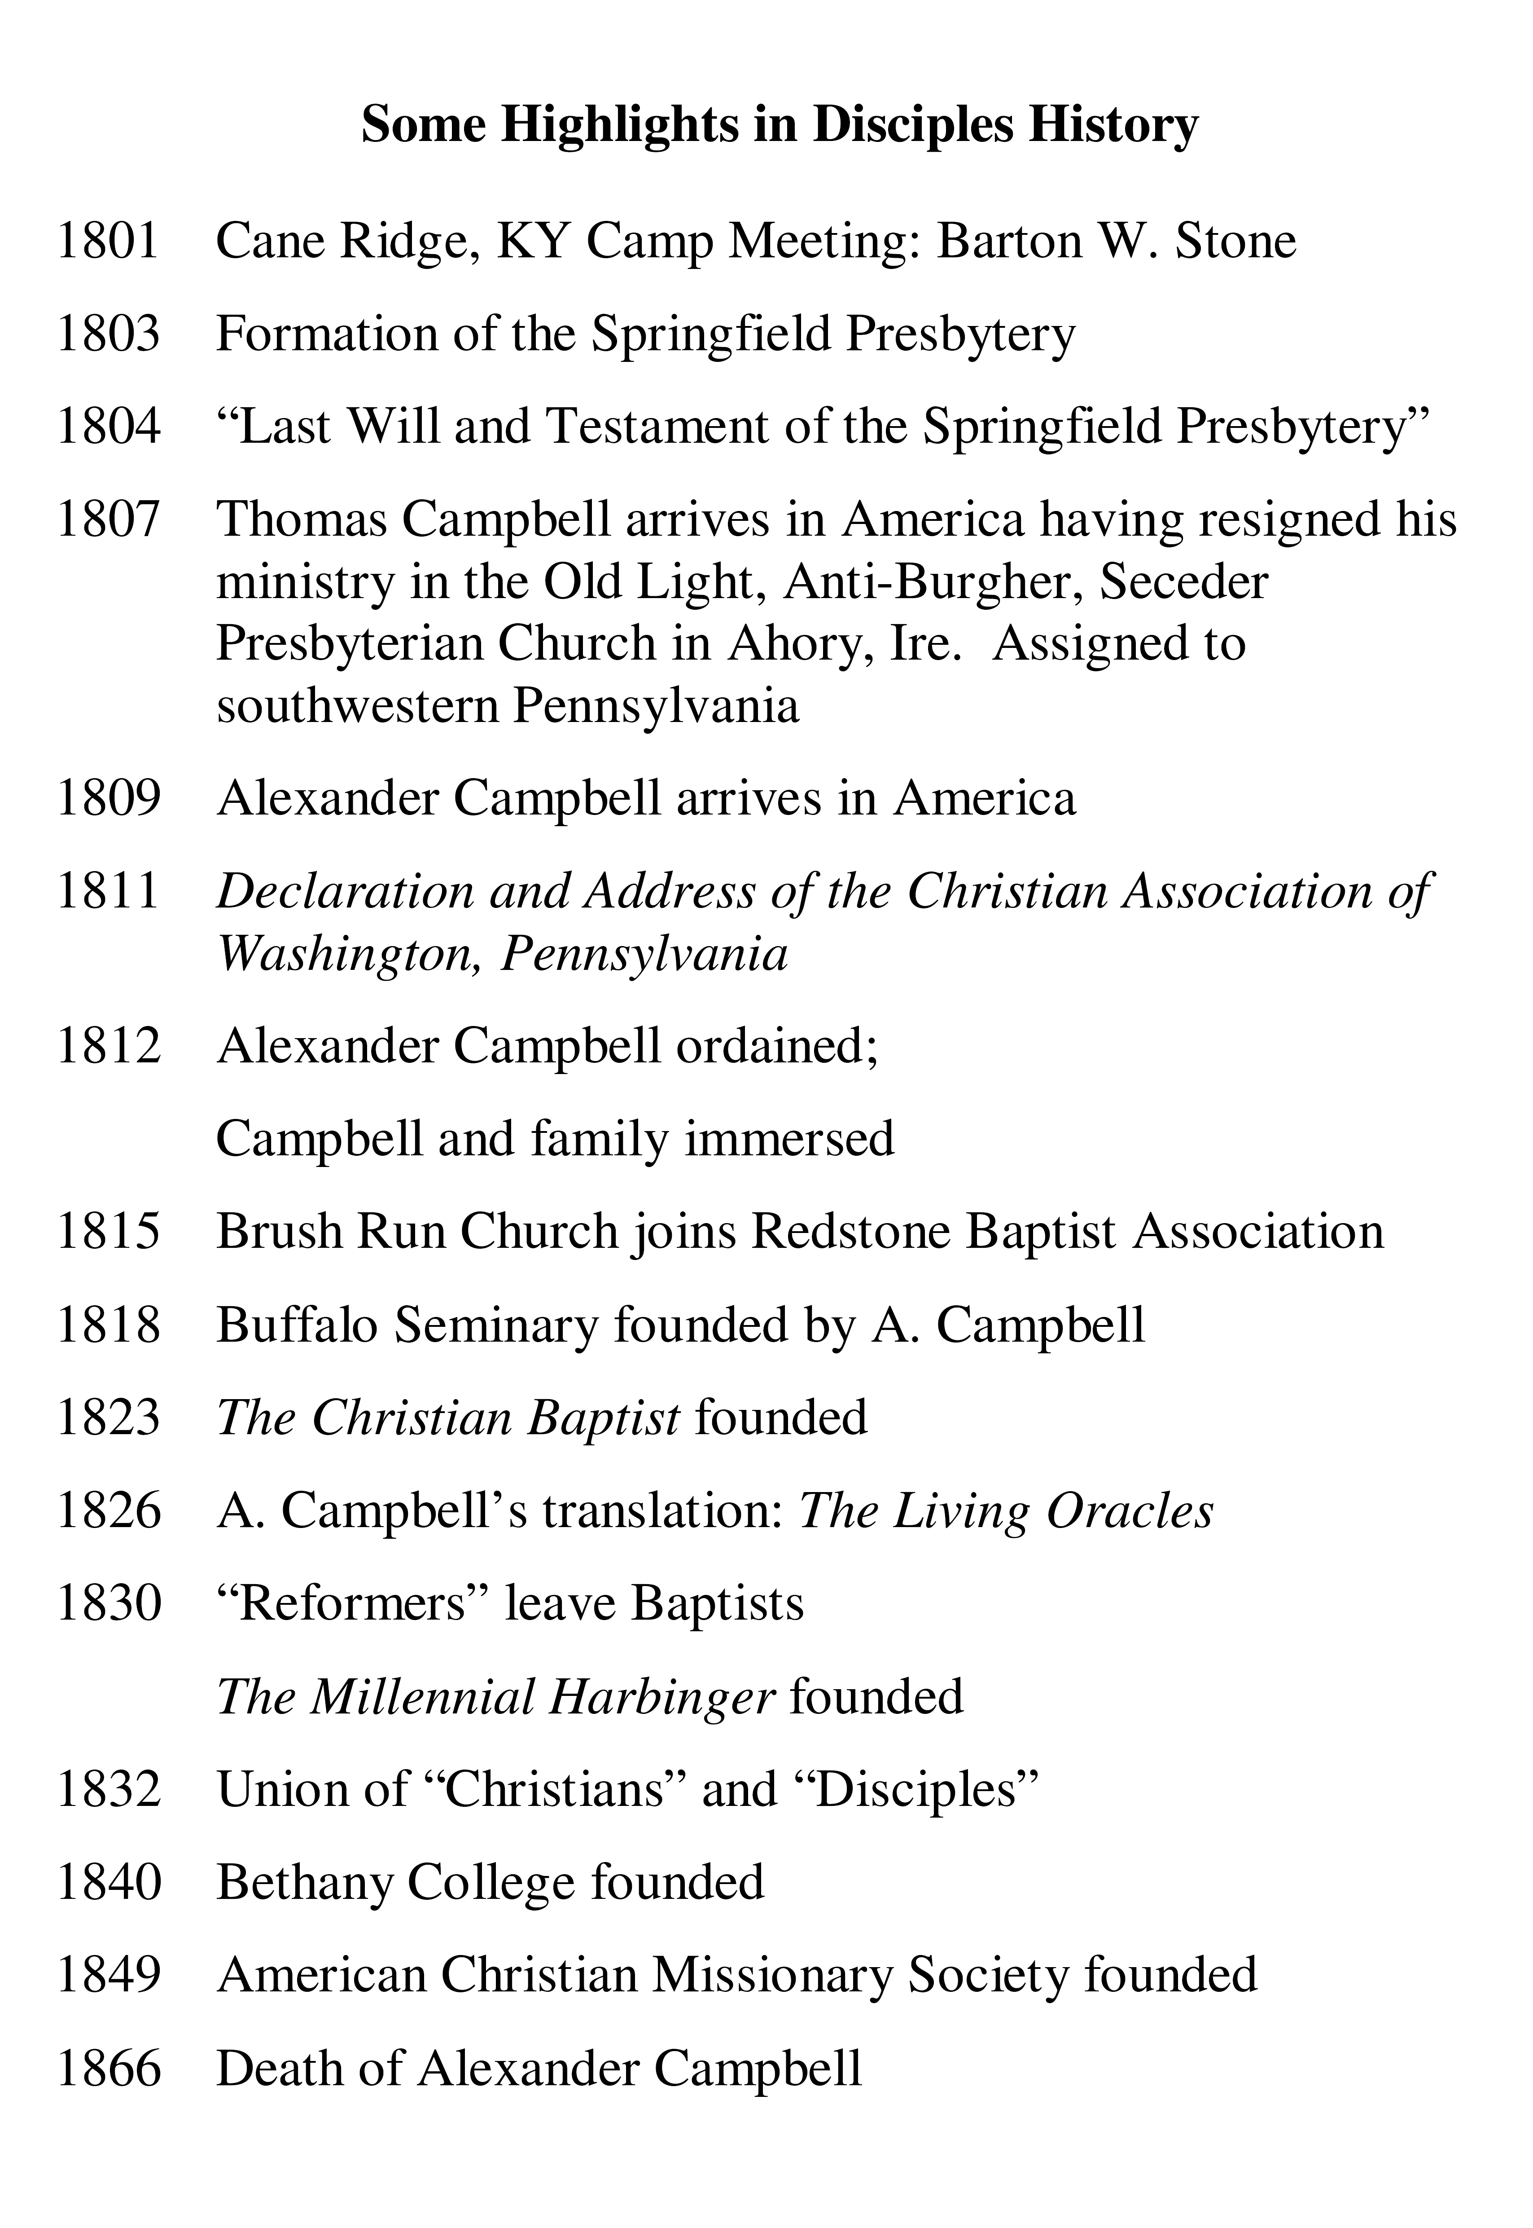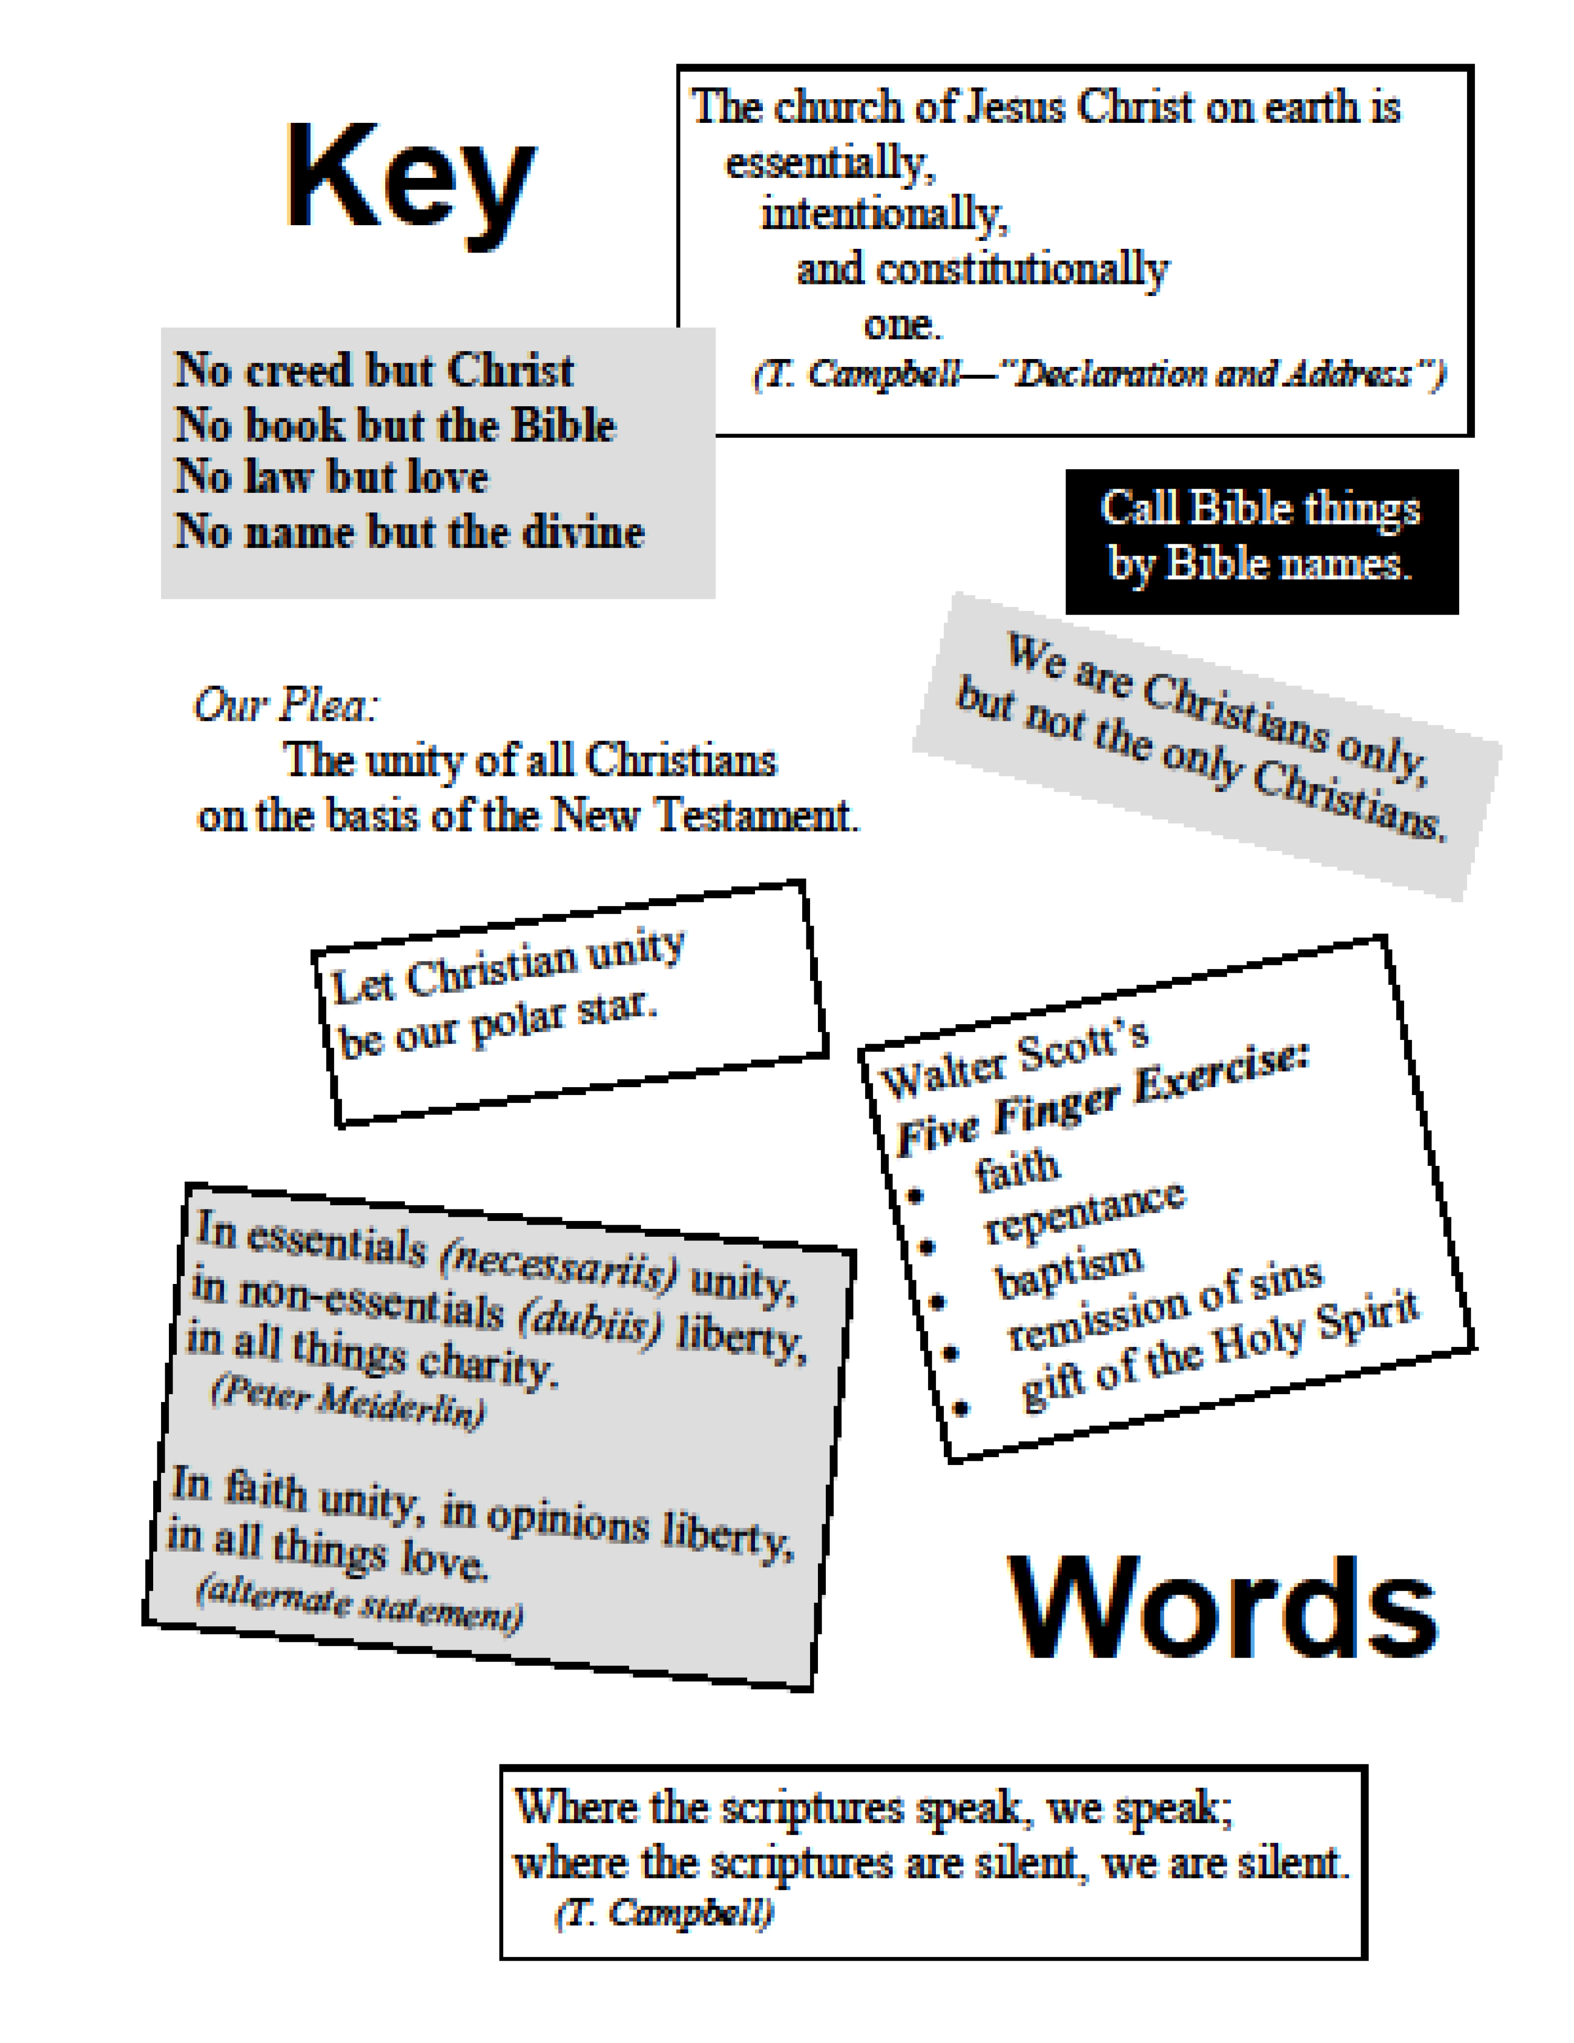
16
17

18

the
Examen

The Examen is a method of reviewing your day in the presence of God. It’s actually an attitude more than a method, a time set aside for thankful reflection on where God is in your everyday life. Our version of the Examen has six steps, which most people take more or less in order, and it usually takes about 15 minutes per day.

- As God for light. I want to look at my day with God’s eyes, not only my own.
- Give thanks. The day I have just lived is a gift from God. I am grateful for it.
- Review the day. I carefully look back on the day as it is ending, being guided by the Holy Spirit.
- Face your shortcomings. I think about what I may have done that was not helpful or not pleasing to God, or challenges I faced without thinking of asking God for help.
- Where did I see God? How did God meet me in my everyday life today?
- Look toward the day to come. I ask God for peaceful rest and help to be faithful in the coming day.

Adapted from Ignatian Spirituality

19

©2010, 2016 by Thaddaeus B. Allen.
Published by the Christian Church (Disciples of Christ) in West Virginia,
1402 Washington Avenue, Parkersburg, WV 26101.
www.WVDisciples.org

